
2101 South 21st Street
Parsons, Kansas 67357
(620) 421-0200

CST Storage Celebrates Five Years Without a Lost Time Accident
Safety Celebration to Include Distribution of Bonuses and Recognition by Parsons Mayor and City Manager

PARSONS, Kan. (May 20, 2013) – It is safe to say that CST Storage, located at 2101 S. 21st Street, is one of the safest manufacturing companies in the state of Kansas. At 2:45 p.m. on Monday, May 20 the company, which currently is celebrating its 41st year in Parsons, will recognize its employees with a ceremony to honor the company’s achievement of five years without a lost time accident.

“Reaching five years without a lost time accident is a highly elusive accomplishment for any company, but for companies in heavy manufacturing, our safety record is nothing short of incredible. It boils down to the dedication of our employees who work every day with a focus on safety, quality and efficiency. We greatly appreciate their tremendous efforts,” said Summer Pommier, Plant Manager for CST Storage.

Joining in the celebration and recognition will be Kevin Cruse, Mayor of Parsons, Fred Gress, City Manager, as well as Declan McLaughlin, President and CEO of CST Industries, parent company of CST Storage, and Steve Westfall, President of CST Storage.

“We are truly proud of our CST Storage employees here in Parsons. Not only are they hardworking and deserving of this honor, but they have also set the example of world class safety throughout our entire company,” said McLaughlin.

As a special thank-you, CST Storage will award each of its employees with a $500 bonus and an additional day of vacation with pay.
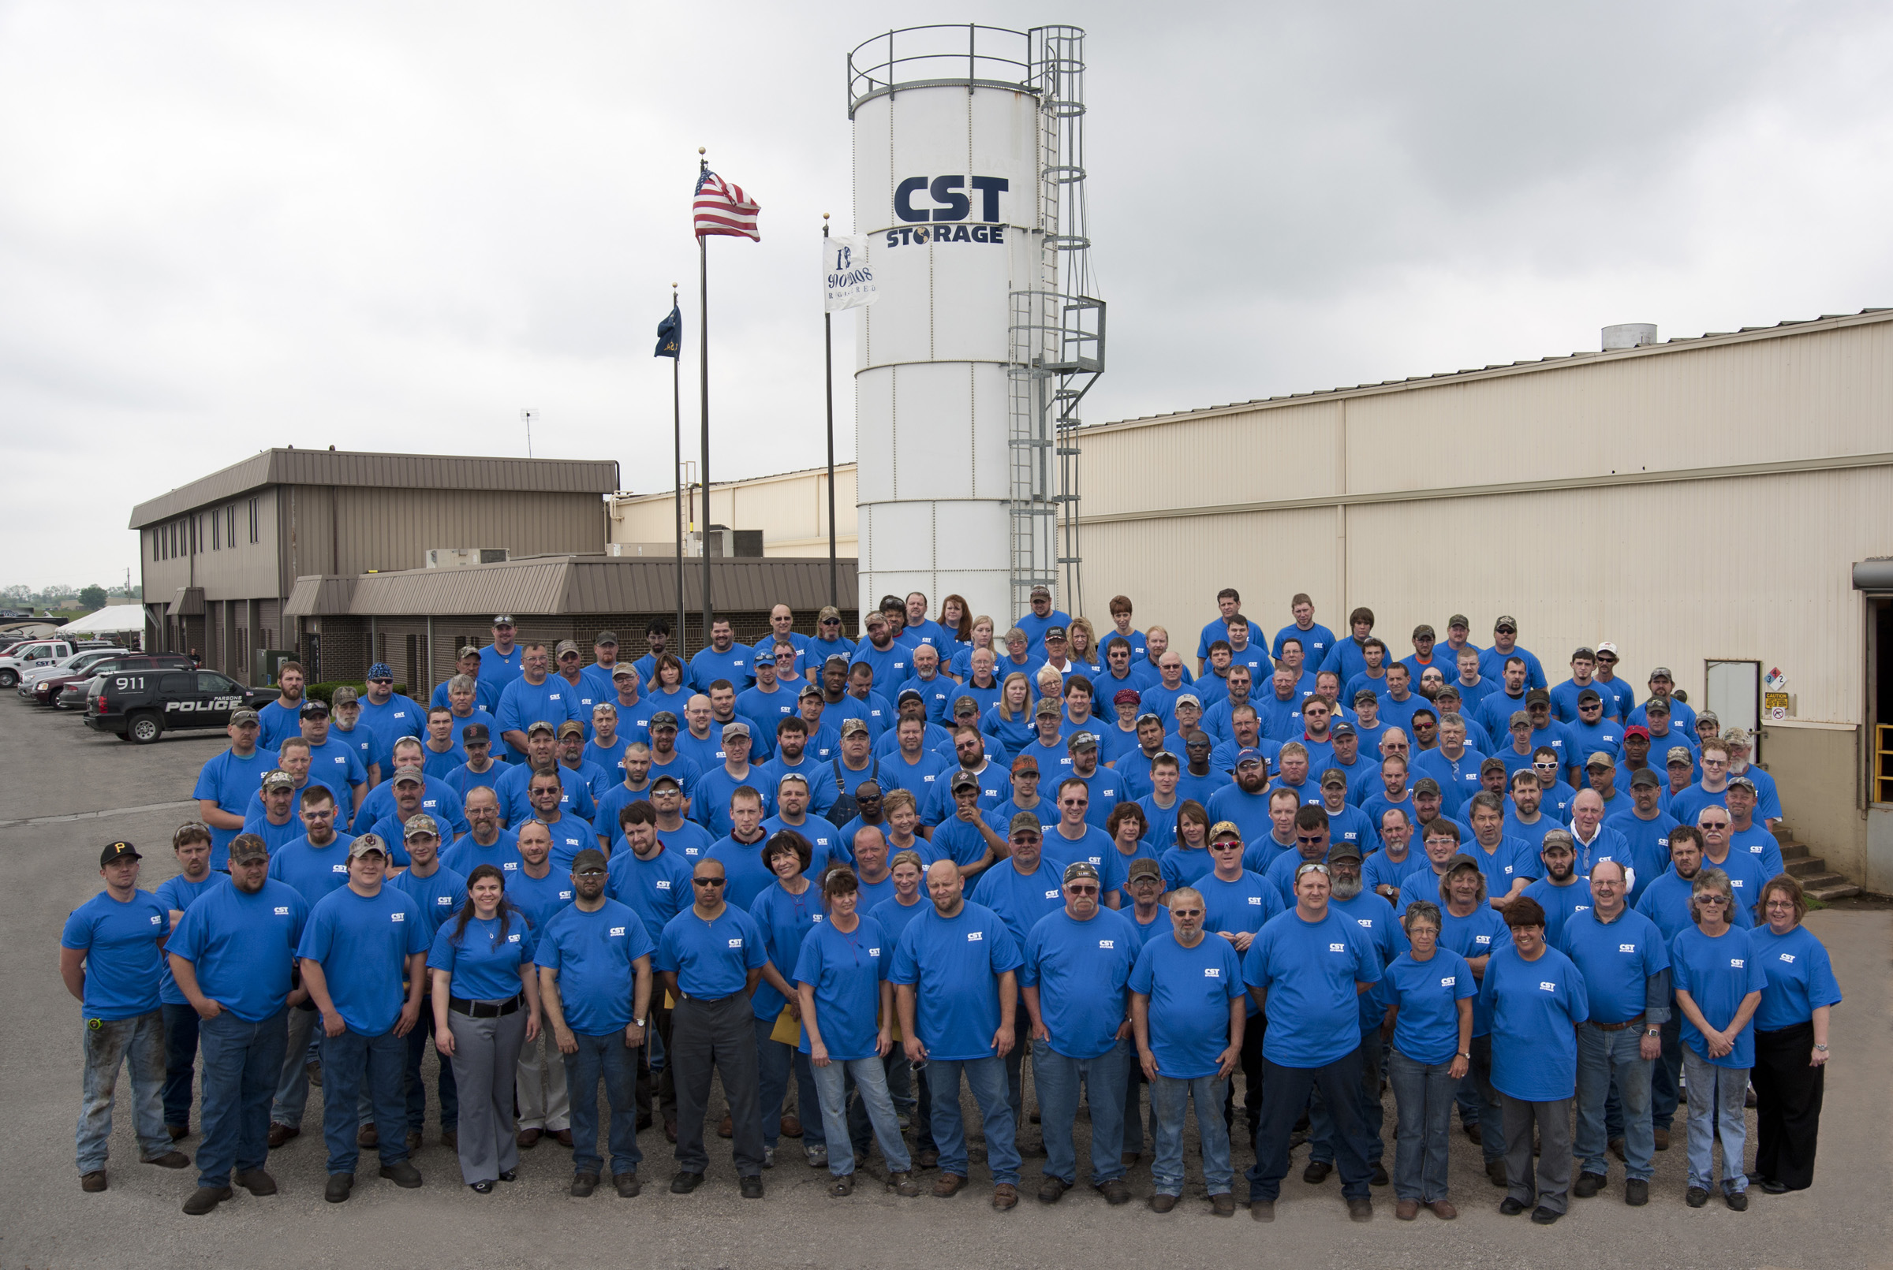

This is not the first time the company has been recognized for its outstanding safety record. Since 2009 the company has been recognized twice by the State of Kansas for its exceptional safety record.

About CST:
Located at 2101 S. 21st Street in Parsons since 1971, CST Storage (www.cst-storage.com) is the world’s largest provider of modular, bolted storage tanks. CST Storage manufactures the leading tank coating technologies in the industry providing both glass-fused-to-steel porcelain enamel (Dekalb, Ill.) and a proprietary cured epoxy system (Parsons, Kan.). CST’s global network includes manufacturing facilities and technical design centers located in Kansas, Tennessee, Illinois, Texas, California, Georgia and the United Kingdom. Regional sales offices are located throughout North America and in Mexico, Argentina, United Kingdom, Dubai, Singapore and Vietnam. For additional information please contact Tiffany Jarman at CST Storage in Parsons at (620) 421-0200 or at tjarman@cst-storage.com.
# # #

