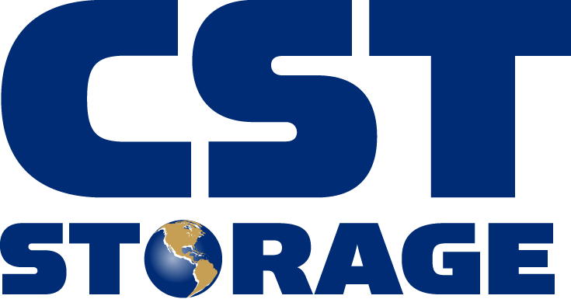
491 Baxter Lane
Winchester, TN 37398
(931) 967-9135

CST Storage Manufacturing Facility Recognizes Employees
for Outstanding Safety Record

CST Storage President Steve Westfall led a recognition ceremony and awarded employees with bonuses on Thursday, July 25, 2013 at CST Storage, located at 491 Baxter Lane in Winchester.

WINCHESTER, Tenn. (July 30, 2013) – Leaders from CST Storage located at 491 Baxter Lane in Winchester, as well as parent company CST Industries were on location July 25, 2013 in Winchester to celebrate and recognize employees for their immense accomplishment of four years without a lost time incident. According to the Bureau of Labor Statistics, the industry average of incidents from 2007 through partial year of 2013 that resulted in lost time had an average of 3.9 days and 3.7 days for the state of Tennessee.

“It is a great honor and privilege to be able to recognize the employees for their dedication to safety. It has taken the focus and team work of each individual to reach four years without a loss time accident. This accomplishment reflects on our entire company as we strive to continue to improve our safety, quality and efficiency to surpass the heavy manufacturing industry standards. We greatly appreciate our employee’s efforts,” said Joe Underwood, Plant Manager for CST Storage.

Joining in the celebration and employee recognition were Joe Underwood, Plant Manager; Steve Westfall, President of CST Storage, as well as Declan McLaughlin, President and CEO of CST Industries, parent company of CST Storage.

As a special thank-you for their accomplishment, CST Storage provided lunch for all its employees and awarded each person with a bonus, one extra day of vacation with pay, and a commemorative t-shirt.

About CST Industries
CST Storage is an American owned company and manufacturer of factory welded and bolted steel storage tanks. The company’s facility in Winchester, Tenn. manufactures high quality welded tanks and silos for use in liquid and dry bulk storage worldwide.

CST Industries (www.cstindustries.com) is the world’s largest provider of storage tanks and aluminum domes and covers. Headquartered in Lenexa, Kan., CST Storage manufactures the leading tank coating technologies in the industry, providing glass-fused-to-steel porcelain enamel and proprietary Optibond® cured epoxy coating systems. CST Industries products are found in 125 countries worldwide.

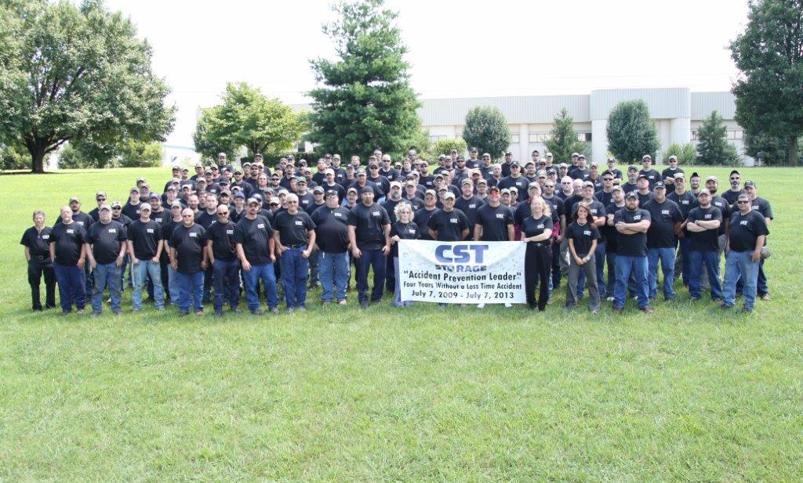

Contact:
Donna Willis, PHR
Manager, Human Resources
491 Baxter Lane
Winchester, TN 37398
(931) 967-9135
dwillis@cst-storage.com

# # #

